Updated on 6/26/2018

PlanSwift
Authored by: Dave Hansen

PlanSwift Import from Excel Tool

User Guide

Table of Contents

Overview 3
Purchasing and Installation 4
Purchasing Plugins 4
Installation and Uninstallation 4
Features 4
How To 5
How to: Prepare an Excel Spreadsheet for Importation into PlanSwift 5
How to: Import the Excel Spreadsheet 8
FAQ 16

Overview
This guide will teach you how to properly use the tools and features found within the PlanSwift Import from Excel Tool plugin. It is designed for use with PlanSwift® Takeoff and Estimating Software. This guide is not meant to be a step-by-step “walk through” document, although it can be used as a reference for getting the work done. If you encounter technical difficulty, consult this guide (including the FAQ section of this user manual) or contact the technical support department at:

PlanSwift® Technical Support
support@PlanSwift.com
1-888-752-6794 ext. 2

PlanSwift also offers additional training. For training options, contact the training department at:
PlanSwift® Training Department
training@PlanSwift.com
1-888-752-6794 ext. 6

Purchasing and Installation

Purchasing Plugins
If you need to purchase PlanSwift or a plugin product, contact the Sales Department at:

PlanSwift® Sales
sales@PlanSwift.com
1-888-752-6794 Ext. 1

Installation and Uninstallation
Installing and uninstalling plugins and starter packs is simple. For installing them, click on the Import Plugin Package icon (arrow 1 in Figure 1) from the PlanSwift Main Ribbon-bar Plugin tab (arrow 3 of Figure 1) and follow the prompts from there. For uninstalling, click on the Uninstall Plugin (arrow 2 in Figure 1) and follow those prompts.

Figure 1

Features
The PlanSwift Import from Excel Tool Plugin adds an Excel Import Tool icon to an Import group on the Templates ribbon-bar tab (see Figure 2). This plugin allows users to create PlanSwift parts from their own Excel spreadsheets and make them available on the Templates ribbon-bar tab. The instructions below will guide new users through the basics of using this plugin. We highly recommend purchasing a training package for accelerated learning and faster customization.

Figure 2
Disclaimer
Any parts or assemblies that a user creates should always be tested and verified by that user to ensure quantities and calculations are accurate. PlanSwift cannot verify the accuracy of parts and assemblies created by the user.

How To

How to: Prepare an Excel Spreadsheet for Importation into PlanSwift
Figure 3 shows an example of a spreadsheet that is ready to be imported into PlanSwift. The name of the template is Test Template.xlsx. The data in your spreadsheet should be created in a similar way.

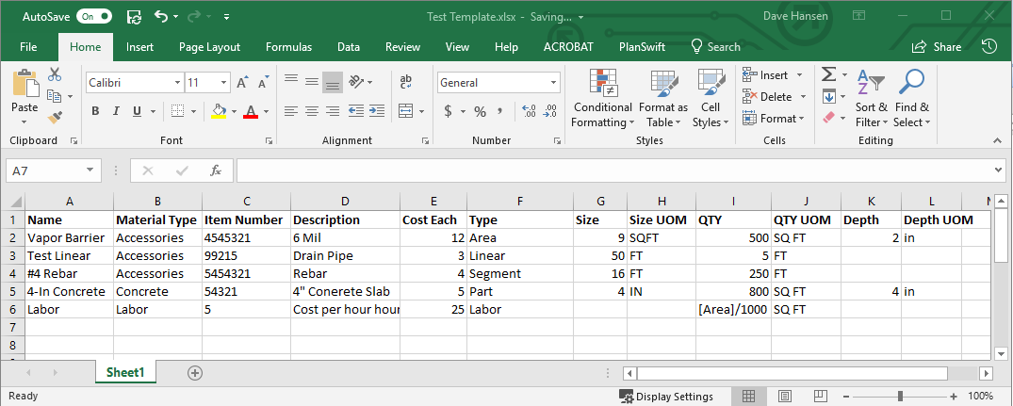
Figure 3

There are several things to consider in preparing an Excel spreadsheet for importation into PlanSwift. Keep in mind that this is a basic example and you are not limited to the properties listed.
- Plan out what properties you want to add and populate for each item.
- Try to be as global as you can with your properties, because each column you create will be added as a property on each item you are importing whether it is used by the item or not.
- To simplify the cleanup work after the import, you can also import the calculations for any given property.

Note
Formulas need to be written in the same manner as in PlanSwift and NOT Excel.

- The first row of your spreadsheet (row 1 on Figure 3) should contain the Property Headings. Note that you will have the opportunity to edit the names that appear in PlanSwift after you run the import tool.
- The Name property (column A in Figure 3) is self-explanatory.
- The Material Type property (column B in Figure 3) helps you to create a folder structure for PlanSwift and will keep your items sorted into tidy categories. Note that your spreadsheet must be sorted by this column before importing; otherwise you will end up with a duplicate folder.
- The Item Number property (column C in Figure 3) is optional and can contain a text description.
- The Description property (column D in Figure 3) contains a text description.
- The Cost Each property (column E in Figure 3) may be included so that cost each can be added as a property.
- The Type property (column F in Figure 3) can contain any of numerous types of properties, some of the most common of which include Area, Linear, Segment, Part, Count, or Labor.
- The Size property (column G in Figure 3) may include the size of the item.
- The Size UOM property (column H in Figure 3) can include the unit of measure (UOM) as a text value (FT, SQ FT, etc.)
- The QTY property (column I of Figure 3) contains a quantity or a formula for a quantity to get the result for the part being counted. You are not limited to the "QTY property" for this. You may add other calculations in the properties you create. Entering formulas is optional, but it can save a great deal of time if you have a lot of items.
- The QTY UOM property (column J in Figure 3) can include the unit of measure (UOM) as a text value (FT, SQ FT, CU FT, etc.) During the import process, you can specify which fields are Units.
- The Depth property (column K in Figure 3) may be used to include a depth value.
- The Depth UOM property (column L in Figure 3) contains a unit of measure (UOM) for the depth column as a text value (FT, SQ FT, etc.)
T

How to: Import the Excel Spreadsheet
Once the spreadsheet is formatted (including sorting on column B) and the data complete, you can start the import process. With the Excel spreadsheet open and PlanSwift open, click on the Excel Import Tool in the Import group of the Templates tab ribbon bar (Figure 2). This launches the tool and opens the Excel Import Tool 1.3 window (Figure 4). The Excel spreadsheet data will load the columns headers automatically. PlanSwift automatically associates column names with default PlanSwift properties when the names are the same.

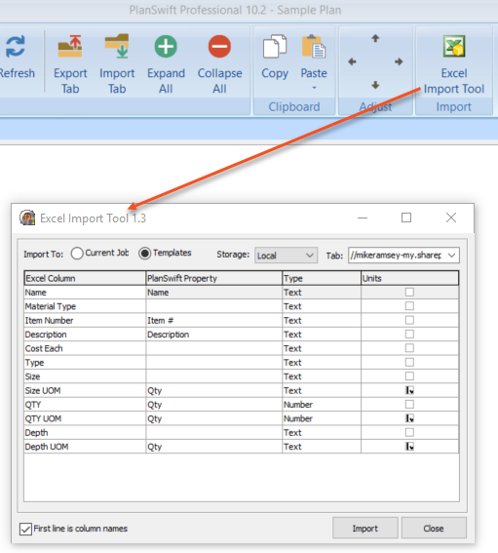
Figure 4

This top area of the Excel Import Tool 1.3 window allows you to select where the parts are to be imported to. The options are Current Job, or Templates. The Storage default is Local, so if you have other than local, such as a network drive, you can select that. The Tab field allows you to give a name to the tab that will be created in the Templates screen. Select a name for the Tab. For this example, we’ll use “Test Template” (Figure 4), so type “Test Template” in the Tab field.

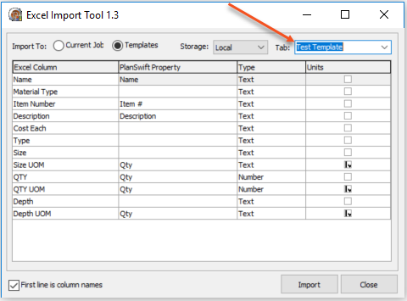
Figure 5

The Excel Column in the window (Figure 5) contains the headings from row one in the Excel Test Template.xlsx file (Figure 3). You can now edit the data in the PlanSwift Property, Type, and Units columns. Clicking once on any of the cells under the PlanSwift Property column and then clicking on the down-arrow opens a drop-down menu (Figure 6).

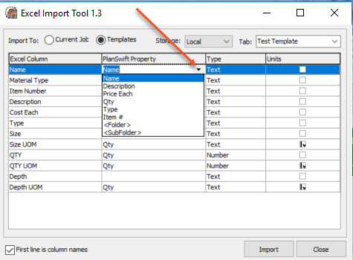
Figure 6

This drop-down menu allows you to select the PlanSwift properties that will be assigned to the Excel Column headings. These properties include but are not limited to Name, Description, Price Each, QTY, Type, Item #, Folder and Subfolder. If you want a property that is not in the drop-down menu, simply type it in and press Enter. Figure 7 shows the PlanSwift Property column cells filled in with valid PlanSwift properties. Note that Material Type (arrow 1 of Figure 7) is not a property in PlanSwift; selecting <Folder> as its property (see arrow 1 of Figure 7) will allow you to create an organized structure for the imported parts using Material Type as the group. Selecting <Sub Folder> as a type allows for a subfolder of a folder to be created as well; subfolders of subfolders, however, are not supported. Note that Depth is not in the drop-down menu but can be typed in (see arrow 2 in Figure 7). For the Size, Depth, and QTY properties, multiple Excel columns have been assigned to a single PlanSwift property.

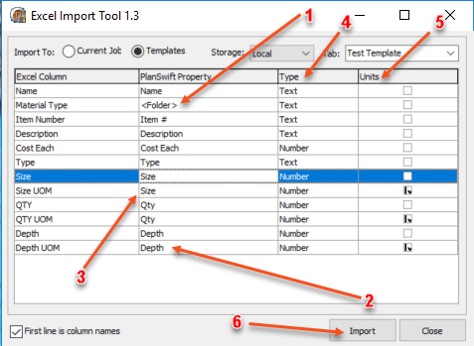
Figure 7

The Type column (arrow 4 of Figure 7) requires the selection of either Text or Number for the type. Click on the cell, then on the down-arrow to make the selection.

The Units column (arrow 5 of Figure 7) should be checked for any property that is a unit of measure. The Size UOM, QTY UOM, and Depth UOM should all be checked because they are units of measure. Note that if you have any item that you want to have use the other item’s unit of measurement, make certain that both items have the same PlanSwift property. For instance, if you want the Size UOM to be the unit of size, then it must have the same PlanSwift property of Size.

Once everything is set the way you want it, click on the Import button (arrow 6 of Figure 7) in the lower right corner.

Once the import tool has finished, you will see the Test Template tab showing in the PlanSwift Templates tab window. Figure 8 shows the imported parts from the Excel spreadsheet.

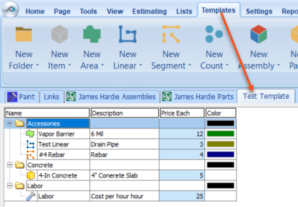
Figure 8

To verify the parts came in correctly, right click on Vapor Barrier and select Properties (see Figure 9).

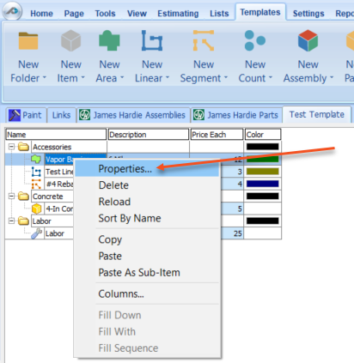
Figure 9

This opens the Properties – [Vapor Barrier] window (Figure 10). Click on Advanced.

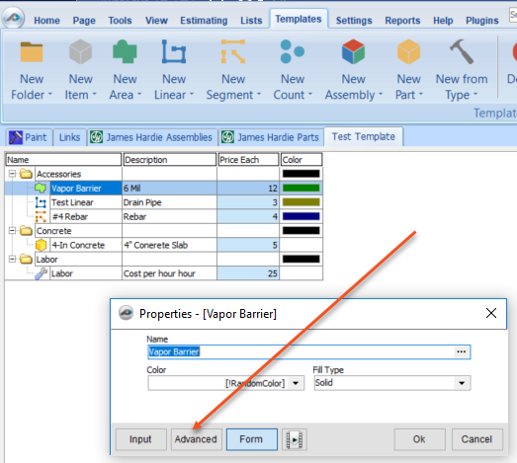
Figure 10

Clicking on Advanced opens the advanced properties window for Vapor Barrier (Figure 11).

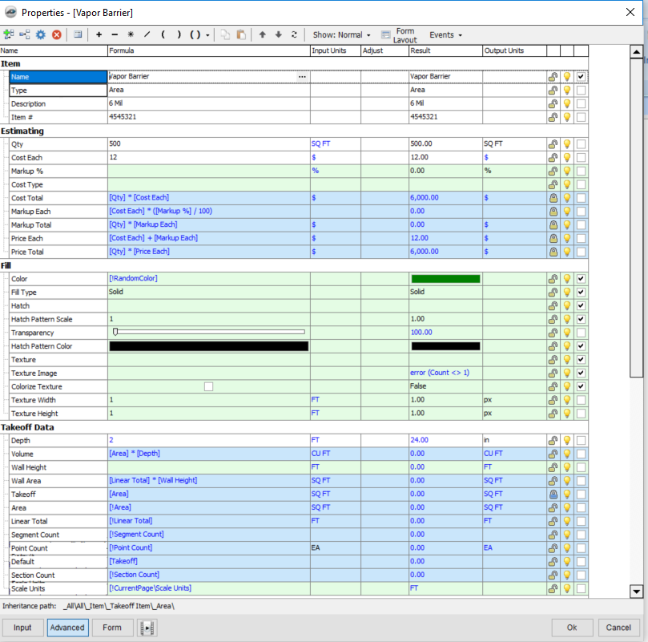
Figure 11

For comparison purposes, Figure 12 shows the Excel spreadsheet, the top part of the advanced properties window for Vapor Barrier, and the imported results in the PlanSwift Template tab. Arrow 1 shows that the advanced properties window is open. Arrow 2 shows that Vapor Barrier was imported from the spreadsheet, and arrow 3 shows that the Vapor Barrier material was placed in the Accessories folder in the Template tab. Note that the other Accessories in the spreadsheet (Test Linear and #4 Rebar) were also placed in the Accessories folder.

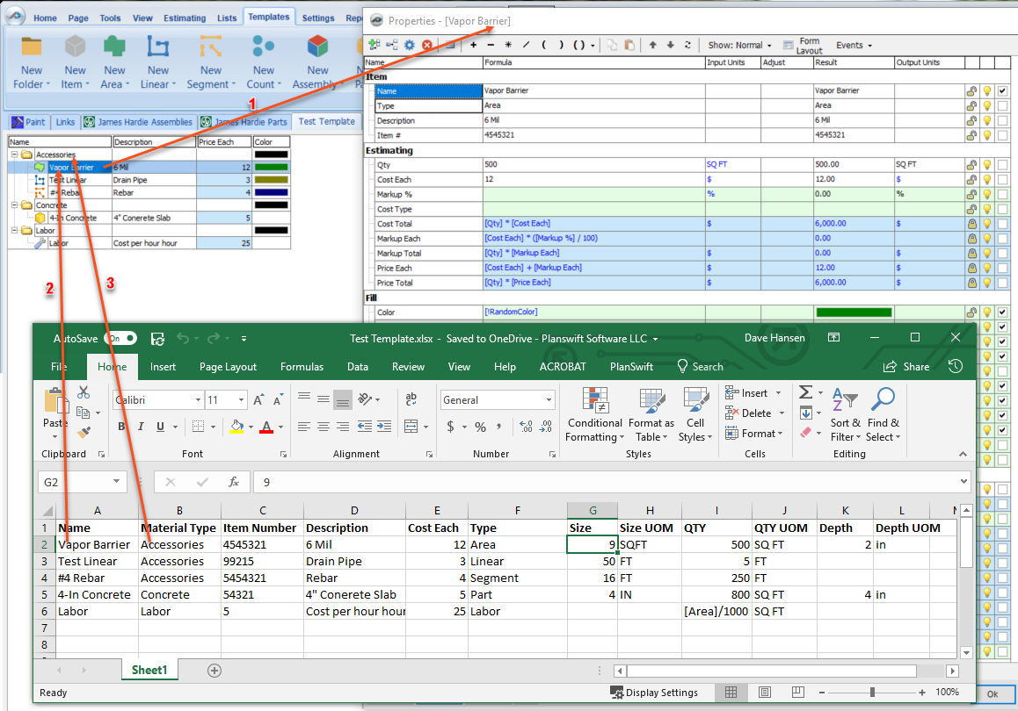
Figure 12

Figure 13 shows the correlation between the spread sheet and some of the spreadsheet properties. As examples, arrows 1, 2, 3, and 4 of Figure 13 show the Vapor Barrier Item Number, Description, Cost Each, and QTY respectively on both the spreadsheet and the advanced properties window.

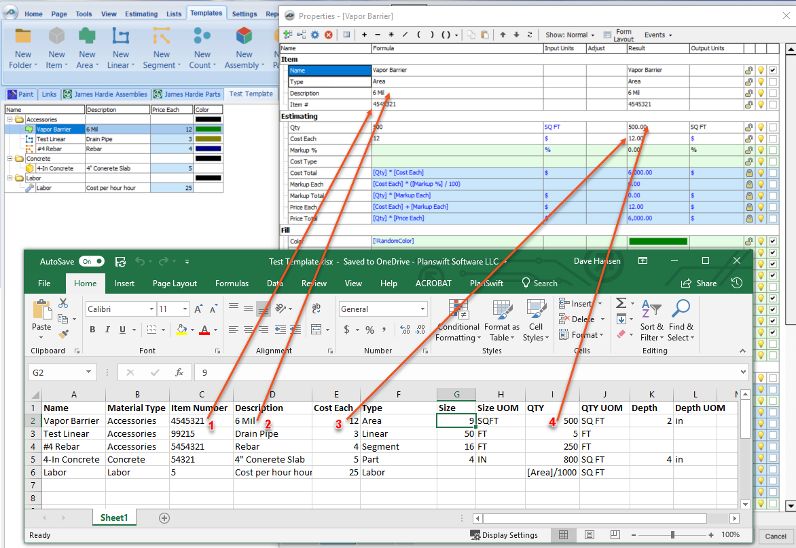
Figure 13

PlanSwift recommends you always do a spot check to make sure the information loaded properly.
Disclaimer
Any parts that a user imports into PlanSwift should always be tested and verified by that user to ensure the parts are imported correctly. PlanSwift cannot verify the importation of parts created by the user.

You are now ready to apply your new parts to a takeoff.

FAQ
Question: I’ve read this user guide, and I still have questions. What do I do?

Answer: PlanSwift recommends that you purchase a training package. We highly recommend new users purchase a training package, because training is customized to each user. We offer one-on-one training and classroom training. Contact training@PlanSwift.com or at 1-888-752-6794 Ext. 6.

Question: Can I import custom properties for the items I have created?

Answer: Yes. If you want a property that is not listed in the drop-down menu, simply type it in and press Enter. It will then be added when you import the spreadsheet.

Question: Can I have subfolders inside of subfolders?

Answer: No. PlanSwift only allows two levels deep of folders, a main folder and a subfolder within the main folder.

Question: What do I do if I import and it is not what I wanted?

Answer: You can delete what you imported, modify the spreadsheet, and then import it again (it is our experience that you may not get it right on your first import).

